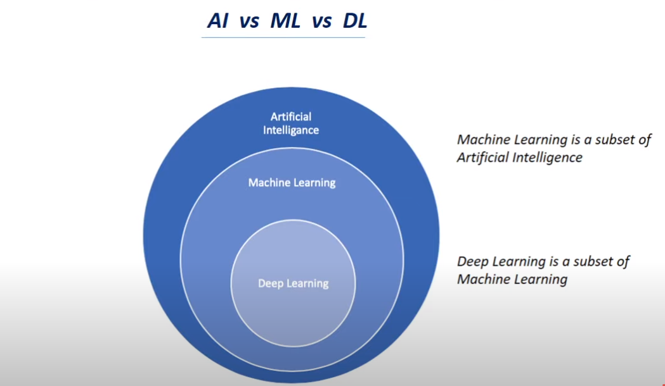
Artificial Intelligence:
it’s a branch of computer science to build smart and intelligent machines.

Difference between intelligent and non intelligent machines :
Intelligent machines are those which can take decisions on their own based upon data
and vice versa for non intelligent machines.

Examples:
Non-Intelligent machines: a normal bike,non-smart watch
Intelligent machines: Smart car,Voice assistant

Machine Learning:
It’s an technique to implement A.I that can learn from the data by themselves without being explicitly programmed.

Examples includes: image classification

Deep Learning:
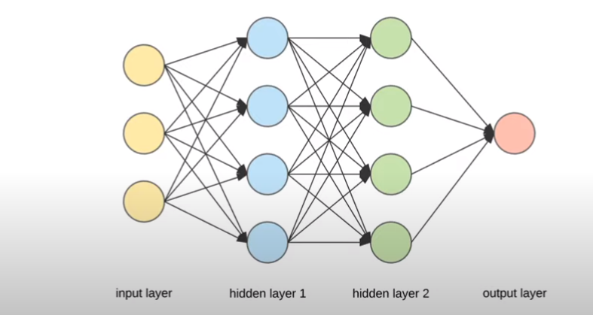
it’s a subfield of machine learning which uses artificial nueral networks to learn from data.

Artifical nueral networks are completely inspired from nuerons inside the brain.

